**PhysioFlex-personal Posture Trainer**



***By***

**Hamza Akram**

**20-ARID-763**

**M Fahad Bashir**

**20-ARID-790**

**Syeda Moniza**

**20-ARID-833**

***Supervisor*Dr. Ruqia Bibi**

**University Institute of Information Technology,**

**PMAS-Arid Agriculture University,**

**Rawalpindi**

**2024**

***Bachelor of Science in Software Engineering (2020-2024)***

**The candidate confirms that the work submitted is their own and appropriate  
 credit has been given where reference has been made to the work of others**.

**DECLARATION**

We hereby declare that this software, neither whole nor as a part has been copied out from any source. It is further declared that we have developed this software documentation and accompanied report entirely on the basis of our personal efforts. If any part of this project is proved to be copied out from any source or found to be reproduction of some other. We will stand by the consequences. No Portion of the work presented has been submitted of any application for any other degree or qualification of this or any other university or institute of learning.

Muhammad Fahad Bashir Hamza Akram Syeda Moniza

--------------------------- ------------------ --------------------

**CERTIFICATE OF APPROVAL**

It is to certify that the final year project of BS (SE) “Physioflex-personal Posture Trainer” was developed by “Muhammad Fahad Bashir **20-Arid-790”**, “Hamza Akram **20-Arid-763”** and “Syeda Moniza **20-Arid-833”** under the supervision of “Dr. Ruqia Bibi” and that in their opinion; it is fully adequate, in scope and quality for the degree of Bachelors of Science in Software Engineering.

---------------------------------------

**(Dr. Ruqia Bibi)**

**Supervisor**

**---------------------------------------**

**(Ms. Nergis Gulzar Abbasi)**

**Examiner I**

**---------------------------------------**

**(Mr. Imran Khurram)**

**Examiner II**

---------------------------------------

**(Prof. Dr. Yaser Hafeez)**

**Director UIIT**

**Executive Summary**

Our project address musculoskeletal health issues related to incorrect postures by introducing an innovative solution. The existing solutions in the field are criticized for lacking a comprehensive approach that integrates real-time posture detection with tailored exercise guidance. Many solutions that are excellent requires subscription. To fill this gap, our project aims to create a web application that serves as a vigilant companion, continuously monitoring users' posture and providing immediate feedback on deviations from correct alignment.

What distinguishes this project is its emphasis on personalization. The system is designed to offer a wide range of exercises tailored to each user's specific postural issues. By seamlessly integrating real-time posture detection with personalized guidance, users will have a powerful tool to rectify their posture habits and foster musculoskeletal health.

The overarching goal of this project is to enhance the quality of life for individuals by addressing the often overlooked aspect of posture. Through real-time monitoring and tailored guidance, the web application is poised to empower users to take proactive steps towards improving their musculoskeletal health.

**Acknowledgement**

All praise is to Almighty Allah who bestowed upon us a minute portion of His boundless knowledge by virtue of which we were able to accomplish this challenging task.

We are greatly indebted to our project supervisor “Dr. Ruqia Bibi” and our Co-Supervisor “Dr. Tariq Ali” for personal supervision, advice, valuable guidance and completion of this project. We are deeply indebted to him for encouragement and continual help during this work.

And we are also thankful to our parents and family who have been a constant source of encouragement for us and brought us the values of honesty & hard work.

Muhammad Fahad Bashir Hamza Akram Syeda Moniza

--------------------------- --------------------------- ---------------------------

**Abbreviations**

|  |  |
| --- | --- |
| **SRS** | Software Requirement Specification |
| **PC** | Personal Computer |
| **SRE** | Software Requirement Engineering |
| **SDLC** | Software Development Lifecycle |

**Table of Contents**

**Introduction 1**

1.1 Brief 1

1.2 Relevance to Course Modules 1

1.3 Project Background 2

1.4 Literature Review 3

1.5 Analysisi form Literature Review 3

1.6 Methodology and Software Life Cycle 4

**Problem Definition** 5

2.1 Problem Statement 5

2.2 Deliverable and Development Requirements 5

2.3 Current System 6

**Requirement Analysis** 8

3.1 Functional Requirments 8

3.2 Non – Functional Requirments 8

3.2.1 Usability………… 8

3.2.2 Reliability 8

3.2.3 Performance 9

3.2.4 Supportability 9

3.2.5 Design Constraints 9

3.2.6 Licensing Requirements 9

3.3 Use case Model 10

3.3.1 Use Case Diagarm 10

3.3.2 Actors Discription 11

3.3.3 Use Case Discription 11

**Design and Architecture** 16

4.1 UML Structural Diagrams 16

4.1.1 Component Diagram 16

4.1.2 Deployment Diagram 17

4.1.3 Class Diagram 18

4.2 UML Structural Diagrams 19

4.2.1 DFD (Level 0) Diagram 19

4.2.2 DFD (Level 1) Diagram 19

4.3 UML Interaction Diagrams 20

4.3.1 Sequence Diagrams 20

**Implementation** 21

5.1 Component Diagram 21

5.2 Network and protocol choice 23

5.3 User Interface 24

**Testing and Evaluation** 28

6.1 Verification 28

6.1.1 Functional Testing 28

6.1.2 Static Testing 28

6.2 Validation 28

6.3 Usability Testing 28

6.4 Unit Testing 28

* 1. Test Cases for Managing Login Functionality 29

6.6 Integration Testing 31

6.7 System Testing 31

6.8 Acceptance Testing 31

6.9 Stress Testing 31

6.10 Hardware Configuration for Tetsing 32

6.11 Evaluation 32

6.12 Deployment 33

6.13 Maintenance34

**Conclusion and Future work**  36

7.1 Conclusion 36

7.2 Future Work 36

7.3 Refrence 36

**List of Figures**

Fig 1.1 Block Diagram 7

Fig 3.1 Use Case Diagram 10

Fig 4.1 Component Diagram 16

Fig 4.2 Deployment Diagram 17

Fig 4.3 Class Diagram 18

Fig 4.4 DFD (Level 0 ) Diagram 19

Fig 4.5 DFD (Level 1) Diagram 19

Fig 4.6 Sequence Diagram 20

Fig 5.1 Home Page 26

Fig 5.2 Main Sections 26

Fig 5.3 Live Pose 27

Fig 5.4 PhysioFlex Assistant 27

**List of Tables**

Table 3.1 Create Account 11

Table 3.2 Log in 12

Table 3.3 Browse Exercise and Training 12

Table 3.4 Search Exercise 13

Table 3.5 View Exercise Details 13

Table 3.6 Start Training 14

Table 3.7 Configure Training Session 14

Table 3.8 Evaluate Session 15

Table 3.9 Log Out 15

**Chapter 1: Introduction**

Musculoskeletal health issues, often stemming from incorrect postures, are pervasive and can lead to discomfort and various health problems. This Final Year Project (FYP) endeavors to address this issue by introducing an innovative solution that combines real-time feedback and personalized exercise recommendations for postural correction.

The existing solutions in the field lack a comprehensive approach that integrates real-time posture detection with tailored exercise guidance. Our project aims to bridge this gap by creating a web application that functions as a vigilant companion, continuously monitoring a user's posture and offering immediate feedback on any deviations from correct alignment.

What sets this project apart is its emphasis on personalization. The system is designed to provide individualized exercise recommendations that cater to each user's unique postural issues. By seamlessly integrating real-time posture detection with personalized guidance, users gain a powerful tool to rectify their posture habits and promote musculoskeletal health.

The ultimate goal of this project is to enhance the quality of life for individuals by addressing an often overlooked aspect of their well-being posture. Through real-time monitoring and tailored guidance, this web application will empower users to take proactive steps towards improving their musculoskeletal health.

* 1. **Brief**

Our aim is to develop a web application that focuses on musculoskeletal health. It aims to address posture-related issues by providing real-time posture feedback and personalized exercise recommendations to improve and maintain good posture. This will be implemented using technologies like TensorFlow.js.

* 1. **Relevance to Course Modules**

Our project is directly aligned with fundamental courses studied during our degree program, providing the essential knowledge and skills crucial for the successful development of our posture correction web application.

**1.2.1 Programming Fundamentals and Object-Oriented Programming:**

These courses have laid a robust foundation, particularly in the realm of back-end development where JavaScript serves as the primary language. The concepts acquired in programming fundamentals and object-oriented programming are fundamental to building the core functionality of our application.

**1.2.2 Data Structures & Algorithms:**

Our proficiency in data structures and algorithms is pivotal in crafting efficient posture correction algorithms. It empowers us to select appropriate data types and implement optimized solutions, ensuring the accuracy and effectiveness of our application.

**1.2.3 Software Requirements Engineering:**

Software Requirements Engineering (SRE) has been a cornerstone in our educational journey, imparting insights and techniques crucial for the conceptualization and construction of projects. The knowledge gained is invaluable in the initial phase of our project, where we gather requirements, ensuring alignment with the real pain points of our target users.

**1.2.4 Database:**

Databases, as the backbone of any web application or software, are addressed through our knowledge gained in this course. It equips us to design and implement a modern, fast, and reliable database, drawing upon fundamental concepts to ensure seamless data management within our application.

**1.2.5 Software Quality Engineering:**

Our understanding of software quality engineering, encompassing testing methodologies and quality assurance, is instrumental in maintaining high standards of quality for our application. It guides us in conducting various types of testing to deliver a reliable and high-quality product to our users.

In summary, the knowledge and skills acquired in these courses directly contribute to the development and success of our posture correction web application. They provide the necessary tools and expertise to tackle the challenges associated with the project, ensuring that we deliver a robust and high-quality solution.

* 1. **Project Background**

The inspiration for this project stems from a pressing need within the field of musculoskeletal health. Patients undergoing physiotherapy often face the challenge of maintaining proper posture, which is essential for their recovery and overall well-being. This need is particularly pronounced in cases where physiotherapists cannot be present at all times to provide real-time guidance and supervision.

Furthermore, engaging a personal trainer or assistant for regular posture correction exercises can be both expensive and time-consuming. Many individuals with musculoskeletal issues find it difficult to access expert guidance consistently, limiting the effectiveness of their exercises.

Recognizing these challenges, our project was conceived to bridge this gap in patient care by developing a web application .We aim to provide an accessible and cost-effective solution. This application serves as a virtual assistant, offering continuous guidance and feedback to users, thereby helping them to rectify their posture issues and improve their musculoskeletal health, all while mitigating the difficulties and time constraints often associated with these endeavors.

* 1. **Literature Review**

**1.4.1 Research:**

Research on "Posture and Musculoskeletal Implications for Students Using Mobile Phones" is highly relevant in the context of the current trend of remote learning. This research can shed light on the impact of extended mobile phone use on posture and musculoskeletal health, which aligns with the concerns our project aims to address.

**1.4.2 Products:**

1. "Wearable Posture Correction Devices" such as the Upright GO 2 Premium are examples of products that are gaining popularity. These devices provide real-time feedback and reminders to users, helping them maintain proper posture. Mentioning specific products like this demonstrates the practical applications of posture correction technology [5].

2. "User-centric Applications" that focus on customization and personalized exercise plans are in line with the user-centered approach we aim to adopt in our project. This trend emphasizes the importance of engaging users actively in their posture correction efforts [6].

3. The idea of "Building a Poor Body Posture Detection & Alert System" aligns with the core objective of our project, which is to develop a real-time posture monitoring and correction system. This could serve as a relevant research direction and product concept for your literature review [3].

**1.5. Analysis from Literature Review**

After reading the above literature reviews and viewing the products come to conclusion that there is need for a solutions that is friendly and have real updates. Many products and services like Phio need subscription and difficult to get access. We have to get program code. Apps like Total Rehab only provides clinical video demo and required subscription.[2]

**1.6. Methodology and Software Lifecycle for This Project**

For our project, we have chosen the agile methodology as the foundation for our software development process. Agile is a dynamic and iterative approach that promotes flexibility and adaptability, making it particularly suitable for our project's nature. Here's how we plan to implement Agile for our software development life cycle (SDLC):

Agile Methodology:

1. **Iterative and Incremental Development:** We will break the project into small, manageable increments or sprints. Each sprint will focus on specific features or functionalities.

2. **Collaborative Teamwork**: Agile encourages close collaboration among team members, including developers, designers, and domain experts. We will work closely with physiotherapists and potential users to ensure that the application meets their needs effectively.

3. **Customer-Centric Approach:** Agile places a strong emphasis on customer feedback. We will regularly demonstrate the application to users, gather their feedback, and use it to refine the features and functionalities, ensuring that the end product is aligned with user expectations.

4. **Flexibility and Adaptability:** Agile allows us to adapt to changing requirements or insights throughout the project. As we delve deeper into the development process, we can adjust our priorities and approaches as needed to achieve the best possible outcomes.

5. **Continuous Testing and Quality Assurance:** Quality is paramount, and Agile integrates testing into every phase of development. This ensures that the application remains stable and reliable at all times.

By adopting the agile methodology, we intend to create a responsive and user-centric posture correction web application. The Agile principles of collaboration, flexibility, and continuous improvement are vital in addressing the evolving needs of physiotherapist patients and providing a solution that is not only effective but also adaptable to changing requirements and user expectations.

**1.6.1. Rationale behind Selected Methodology**

We selected the Agile methodology and a corresponding software development life cycle (SDLC) due to their adaptability and user-centric approach. Agile's flexibility allows us to respond to changing requirements and gather continuous user feedback. The chosen SDLC aligns with Agile's iterative development, ensuring incremental progress and regular testing to maintain high-quality standards. Both methodologies are well-suited for our posture correction project, enabling us to create an effective, user-driven solution that addresses evolving needs in musculoskeletal health.

**Chapter 2: Problem Definition**

**2.1. Problem Statement**

In the field of musculoskeletal health, there exists a significant challenge related to maintaining correct postures, especially for patients undergoing physiotherapy. Incorrect postures can hinder the healing process, lead to discomfort, and contribute to long-term health issues. The current solutions often lack the integration of real-time posture detection and personalized exercise guidance, making it difficult for individuals to receive immediate feedback and tailored recommendations to rectify their posture habits. This deficiency in the current approach creates a pressing need for a solution that offers real-time posture monitoring and personalized exercise recommendations, addressing the pain points of physiotherapist patients and others seeking to improve their posture.

**2.2. Deliverables and Development Requirements**

**2.2.1 Deliverables**:

1. **Posture Correction Web Application:** The primary deliverable is a fully functional web application that provides real-time posture monitoring and personalized exercise recommendations. Users should be able to access and use this application seamlessly.
2. **User Documentation**: Clear and comprehensive user documentation, including guides and tutorials on how to use the application effectively.
3. **System Documentation**: In-depth system documentation detailing the application's architecture, codebase, and any APIs used.
4. **Testing and Quality Assurance Reports**: Documentation of rigorous testing and quality assurance efforts, ensuring the application's reliability and accuracy.

5. **Maintenance and Support Plan:** A plan outlining ongoing maintenance, updates, and user support to ensure the application remains effective and up-to-date.

**2.2.2 Development Requirements:**

1. **Programming Languages**: Proficiency in web development languages such as JavaScript, HTML, and CSS is essential. Additional skills in Python or other languages may be required for backend development.

2. **Frontend Development:** Expertise in frontend frameworks like React for creating the user interface and ensuring a user-friendly experience.

3. **Backend Development:** Competence in backend technologies like Node.js, Express, and databases (e.g., MongoDB) for handling data and real-time monitoring.

4. **Machine Learning and AI:** Knowledge of machine learning algorithms for posture detection and AI for personalized exercise recommendations.

5. **Database Management:** Skills in designing, implementing, and maintaining databases to store user data and posture information.

6. **Security Measures**: Implementation of robust security measures to protect user data and ensure compliance with privacy regulations.

7. **User Experience (UX) Design**: Incorporation of effective UX design principles to create an intuitive and engaging interface.

8. **Testing and Quality Assurance**: Rigorous testing methodologies to ensure the application's reliability, accuracy, and overall quality.

These Deliverables and development requirements are essential for the successful implementation of the posture correction web application, aligning with the project's goals and objectives.

**2.3. Current System**

PhysiApp is the companion app to Phys track, the platform that lets healthcare providers such as physiotherapists create and prescribe clinical exercise programs and conduct Telehealth consultations.

When you use PhysiApp, your healthcare provider can accurately monitor your progress and feedback, allowing them to provide better support based on real data. Clinical studies confirm that apps like ours can help improve outcomes for patients [1].

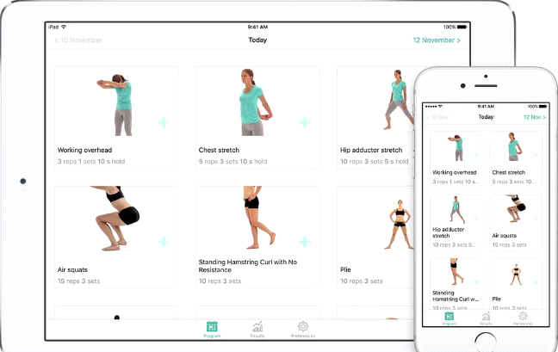

**Figure 1.1: PhysiApp**

**Chapter 3: Requirement Analysis**

**3.1. Functional Requirements**

Following are the functional requirements for our project.

**User Authentication and Profile Management:**

The system shall provide secure user authentication, allowing users to create accounts and log in securely. Users should have the capability to create and manage personalized profiles, including essential details and preferences.

**Real-time Posture Monitoring:**

The application shall employ real-time posture detection mechanisms, utilizing camera inputs to continuously monitor the user's posture. The system should provide immediate feedback to the user regarding deviations from correct posture alignment.

**Personalized Exercise Recommendations:**

The application shall offer tailored exercise recommendations based on the user's unique postural issues. These exercise recommendations should be adaptive, evolving as the user progresses in their posture correction journey.

**Data Storage and Management:**

The application shall securely store user data, including posture history and exercise preferences. Data management should adhere to privacy and security standards, with robust backup and recovery mechanisms in place.

**Exercise Selection and Customization:**

The system shall provide users with a diverse catalog of posture correction exercises, categorizing them based on specific purpose .Users should have the capability to select exercises based on personal preferences, allowing for a customizable and engaging workout routine.

The application shall offer detailed descriptions and visual guides for each exercise, aiding users in understanding and performing them accurately.

**3.2. Non-Functional Requirements**

**3.2.1. Usability:**

The user interface shall adhere to established design principles, ensuring an intuitive and visually appealing experience.

**3.2.2. Reliability:**

The system shall incorporate effective error handling mechanisms to provide users with clear and informative error messages.

**3.2.3. Performance:**

The application shall respond to user inputs within 3 seconds to ensure a seamless and responsive user experience.

**3.2.4.** **Supportability:**

It should be designed with robust Supportability features to ensure ease of maintenance, updates, and troubleshooting. This includes:

Modularity: The system should be modular, allowing for straightforward updates and modifications to individual components without affecting the entire application.

Documentation: Comprehensive documentation for system architecture, code base, and APIs should be provided to facilitate efficient troubleshooting, updates, and future development.

User Support: A user-friendly support system, including FAQs, user guides, and a responsive help desk, should be in place to assist users with any queries or issues.

**3.2.5. Design Constraints**

Browser Compatibility: The application should be compatible with major web browsers such as Chrome, Firefox, Safari, and Edge to ensure a consistent user experience.

Network Requirements: The application should perform optimally under standard internet connectivity conditions, accommodating users with varying network speeds.

**3.2.6. Licensing Requirements**

The posture correction web application will adhere to the following licensing requirements:

Open Source Licensing: The application will be released under an open-source license, providing users with the freedom to view, modify, and distribute the source code.

Commercial Use: Users will be permitted to use the application for both personal and commercial purposes, encouraging widespread adoption.

Compatibility: The selected license should be compatible with other open-source licenses to promote collaboration within the development community.

**3.3. Use Cases Model**

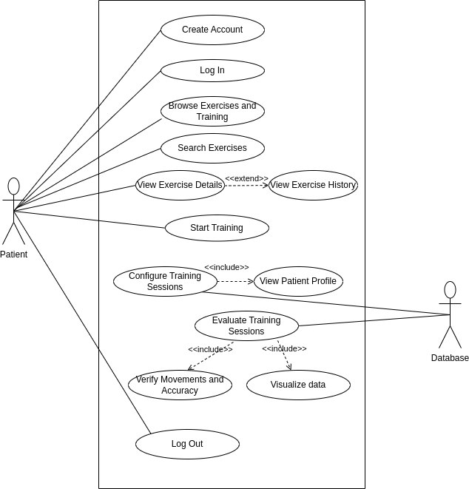

**Fig 3.1: Use Case Diagram**

**3.4. Actors Description:**

**Primary Actors:**

The primary actor is the end-user who interacts directly with the posture correction web application. Users engage in activities such as logging in, monitoring their posture in real-time, receiving feedback, selecting exercises, and viewing progress. The user is the focal point of the system and directly benefits from the application's features.

**Secondary Actor:**

An administrator may be considered as a secondary actor responsible for managing system settings, user accounts, and ensuring the overall functionality and security of the posture correction web application.

**3.5. Use cases Description**

Use cases are a widely used and highly regarded format for capturing requirements.

|  |  |
| --- | --- |
| **Use Case ID:** | UC-1.2.1 |
| **Use Case Name:** | Create Account |
| **Actors:** | Patient |
| **Description:** | This use case involves the process of registering and creating a user account within the system. |
| **Trigger:** | The user wants to create a new account. |
| **Preconditions:** | The user is not logged in and does not have an existing account. |
| **Post conditions:** | The user's account is successfully created. |
| **Normal Flow:** | The user accesses the registration page.  The user provides the necessary information, including username, email, and password.  The system validates the information. The system creates a new user account.  The system sends a confirmation or welcome email to the user. |
| **Exceptions:** | If the provided information is incomplete or invalid, the system displays an error message and does not create the account. |
| **Assumptions:** | The user has access to a valid email address for account verification. |

**Table 3.1: Create Account**

|  |  |
| --- | --- |
| **Use Case ID:** | UC-1.2.2 |
| **Use Case Name:** | Log In |
| **Actors:** | Patient |
| **Description:** | This use case allows the user to access their account by providing valid credentials. |
| **Trigger:** | The user wants to log in. |
| **Preconditions:** | The user has a registered account. |
| **Post conditions:** | The user is successfully logged into their account. |
| **Normal Flow:** | The user accesses the login page.  The user enters their username or email and password.  The system validates the credentials.  If the credentials are valid, the user is logged into their account. |
| **Exceptions:** | If the credentials are invalid, the system provides an error message, and the user is not logged in. |
| **Assumptions:** | The user remembers their login credentials. |

**Table 3.2: Log in**

|  |  |
| --- | --- |
| **Use Case ID:** | UC-1.2.3 |
| **Use Case Name:** | Browse Exercise and Training |
| **Actors:** | Patient |
| **Description:** | This use case allows the user to explore the available exercises and training materials. |
| **Trigger:** | The user wants to browse and explore exercises and training options  The user wants to end their current session and log out. |
| **Preconditions:** | The user is logged in to their account. |
| **Post conditions:** | The user can view available exercises and programs. |
| **Normal Flow:** | The user navigates to the "Browse Exercises and Training" section.  The system displays a list of available exercises and training programs.  The user can click on an exercise or program to view more details. |
| **Exceptions:** | None |
| **Assumptions:** | The user is interested in exploring available exercises and training sessions. |

**Table 3.3: Browse Exercise and Training**

|  |  |
| --- | --- |
| **Use Case ID:** | UC-1.2.4 |
| **Use Case Name:** | Search Exercises |
| **Actors:** | Patient |
| **Description:** | This use case allows the user to search specific exercise that is recommended by the doctor. |
| **Trigger:** | The user intends to find specific exercises. |
| **Preconditions:** | The user is logged into their account and is on the "Browse Exercises and Training" section. |
| **Post conditions:** | The user receives search results for specific exercises. |
| **Normal Flow:** | The user uses a search feature to input keywords, exercise names, or other search criteria.  The system processes the search query and provides a list of exercises that match the search criteria.  The user can click on a specific exercise from the search results to view more details. |
| **Exceptions:** | If there are no search result, system will notifies the user with an appropriate message. |
| **Assumptions:** | The user is looking for specific exercises and uses the search feature accordingly. |

**Table 3.4: Search Exercise**

|  |  |
| --- | --- |
| **Use Case ID:** | UC-1.2.5 |
| **Use Case Name:** | View Exercise Details |
| **Actors:** | Patient |
| **Description:** | This use case allows the user to view exercises details. View Exercise Details could be seen as an optional extension of “View Exercise History”. This means that while viewing exercise history, the user can optionally choose to view additional details for a specific exercise. |
| **Trigger:** | The user wants to learn more about a particular exercise. |
| **Preconditions:** | The user is logged in and has selected specific exercise. |
| **Post conditions:** | The user views detail information of specific exercise. |
| **Normal Flow:** | The user selects a specific exercise from the list of available exercises.  The system displays comprehensive exercise information, including step by step instructions, images, videos, recommended sets, and repetitions. |
| **Exceptions:** | If exercise details are unavailable, system will notifies the user. |
| **Assumptions:** | The user is interested in learning about a specific exercise and intends to follow it. |

**Table 3.5: View Exercise Details**

|  |  |
| --- | --- |
| **Use Case ID:** | UC-1.2.6 |
| **Use Case Name:** | Start Training |
| **Actors:** | Patient |
| **Description:** | This use case allows the user to start their exercise session. |
| **Trigger:** | The user is ready to start a training session. |
| **Preconditions:** | The user is logged into their account and has selected a training program or exercise. |
| **Post conditions:** | The user completes the training session and progress is recorded. |
| **Normal Flow:** | The user selects a training program or a specific exercise they wish to perform.  The system provides instructions and sets a workout timer.  The user follows the instructions and performs the exercises.  The system tracks the progress and records the session, including completion status and performance metrics. |
| **Exceptions:** | If there are technical issues or interruptions during the session, the system provides an option to resume or restart. |
| **Assumptions:** | The user is prepared to engage in training sessions and has selected program or exercise. |

**Table 3.6: Start Training**

|  |  |
| --- | --- |
| **Use Case ID:** | UC-1.2.7 |
| **Use Case Name:** | Configure Training Sessions |
| **Actors:** | Database |
| **Description:** | This composite use case involves configuring and conducting a training session for a patient, including the steps to view patient profile. |
| **Trigger:** | It will determine when and how to initiate training sessions. |
| **Preconditions:** | The physiotherapist is logged into their account.  The patient has a registered account. |
| **Post conditions:** | The training session is successfully configured and completed |
| **Normal Flow:** | The physiotherapist accesses the patient's profile.  The system displays the patient's profile, including relevant health information.  The physiotherapist initiates the training session.  The system evaluates the training session. |
| **Exceptions:** | If there are technical issues or data inaccuracies during the session, the physiotherapist can choose to reschedule or repeat the session. |
| **Assumptions:** | The physiotherapist has the necessary credentials to access patient profiles and initiate sessions.  The patient is present and ready for the training session. |

**Table 3.7: Configure Training Session**

|  |  |
| --- | --- |
| **Use Case ID:** | UC-1.2.8 |
| **Use Case Name:** | Evaluate Training Sessions |
| **Actors:** | Database |
| **Description:** | This use case will evaluate the training session, verify movement and accuracy, visualize data. |
| **Trigger:** | The system will access the effectiveness and progress of the training session. |
| **Preconditions:** | The training session has been completed.  Relevant session data, such as patient performance and exercise information, is available. |
| **Post conditions:** | The training sessions are evaluated and assessments results are recorded in the system. |
| **Normal Flow:** | The system verifies movement and accuracy in real-time.  The system visualizes data and progress for the patient and the physiotherapist.  The system provides access to session data, including exercise performance, patient feedback, and any real-time movement analysis. |
| **Exceptions:** | If there are technical issues or data inaccuracies during the evaluation, the physiotherapist can choose to repeat the evaluation or contact technical support. |
| **Assumptions:** | The system can evaluate and visualize training data effectively. |

**Table 3.8: Evaluate Sessions**

|  |  |
| --- | --- |
| **Use Case ID:** | UC-1.2.9 |
| **Use Case Name:** | Log Out |
| **Actors:** | Patient |
| **Description:** | This use case allows the user to log out from the application. |
| **Trigger:** | The user wants to end their current session and log out. |
| **Preconditions:** | The user is currently logged in to their account. |
| **Post conditions:** | The user is successfully logged out and current session is terminated. |
| **Normal Flow:** | The user clicks on the "Log Out" button or option.  The system logs the user out.  The user is redirected to the login or home page. |
| **Exceptions:** | None |
| **Assumptions:** | The user wishes to secure their account by logging out. |

**Table 3.9: Log out**

**Chapter 4: Design and Architecture**

* 1. **UML Structural Diagrams**

**4.1.1. Component Diagram:**

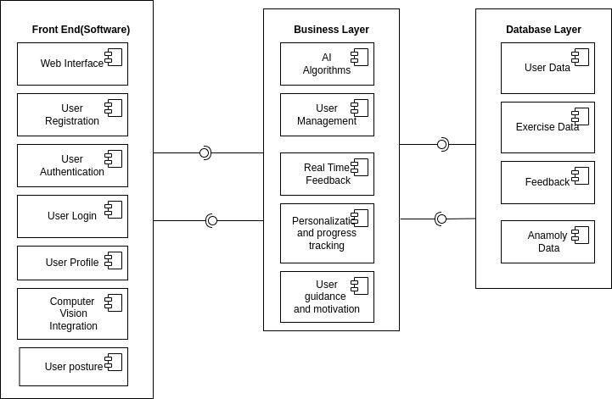

**Fig 4.1: Component Diagram**

**4.1.2. Deployment Diagram:**

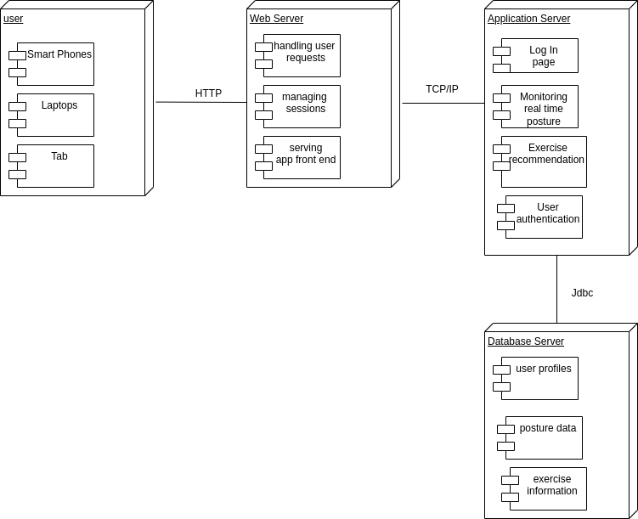

**Fig 4.2: Deployment Diagram**

**4.1.3. Class Diagram:**

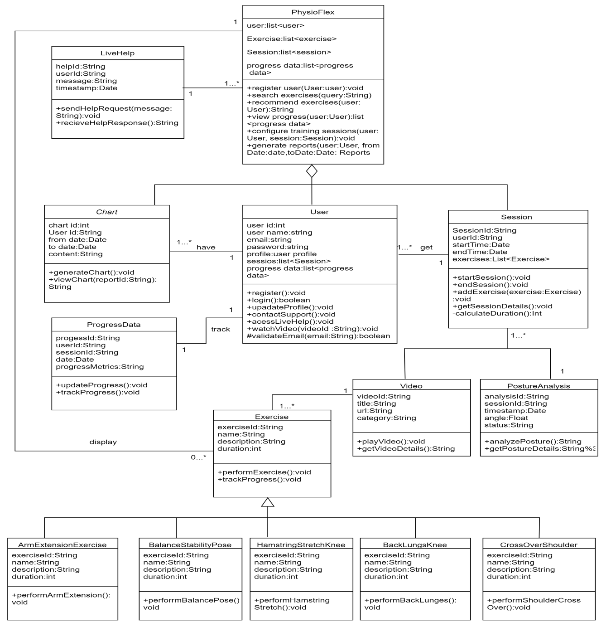

**Fig 4.3: Class Diagram**

* 1. **UML Structural Diagrams**

**4.2.1. DFD (Level 0 ) Diagram**

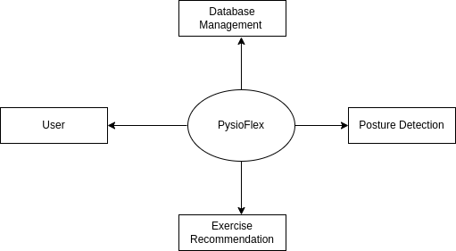

**Fig 4.4: DFD (Level 0) Diagram**

**4.2.2. DFD (Level 1) Diagram**

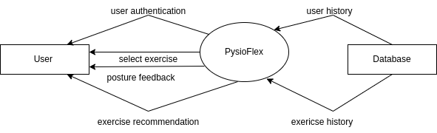

**Fig 4.5: DFD (Level 1) Diagram**

**4.3. UML Interaction Diagrams**

**4.3.1. Sequence Diagram**

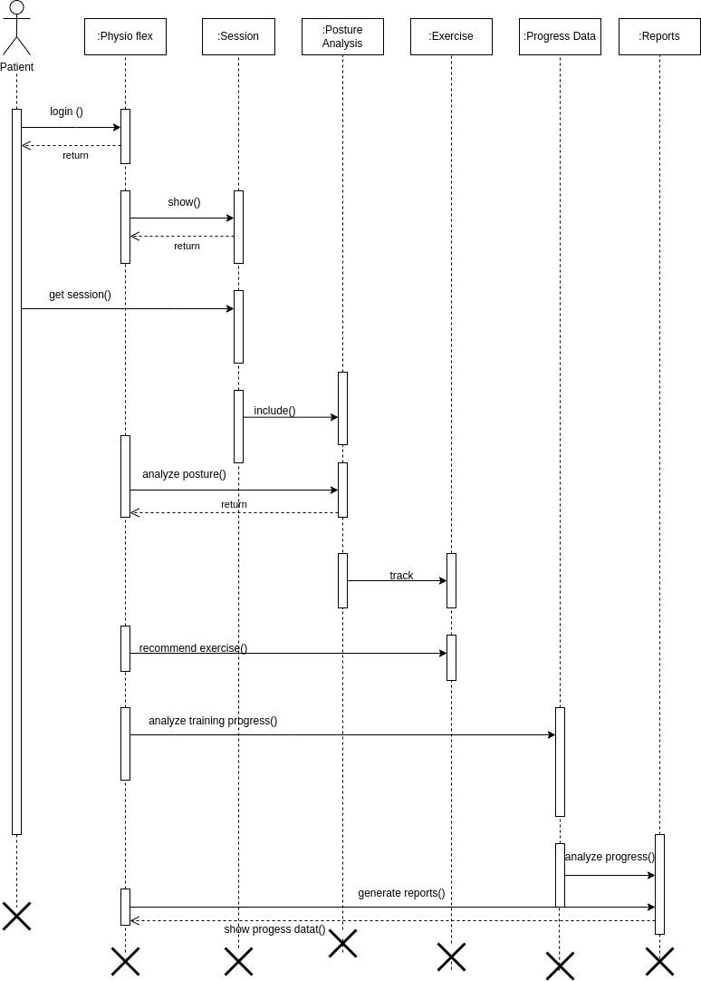

**Fig 4.6: Sequence Diagram**

**Chapter 5: Implementation**

**5.1. Component Diagram**



**Front End (Software) Layer**

1. **Web Interface:**

This component refers to the graphical user interface (GUI) elements that users interact with, including buttons, forms, menus, and visual elements. It provides the means for users to register, log in, manage their profiles, and interact with the application's features.

2. **User Registration:**

This functionality allows new users to create accounts within the application. It typically involves collecting user information such as name, email, password, and possibly additional details for profile setup.

3. **User Authentication:**

User authentication verifies the identity of users during the login process. It ensures that only authorized users with valid credentials can access the application and its functionalities.

4**. User Login:**

User login enables registered users to access their accounts by providing their credentials (username/email and password). Successful login grants access to personalized features and content.

5. **User Profile Management:**

This component enables users to view and update their profile information, such as contact details, preferences, profile picture, and any additional settings relevant to their experience within the application.

6. **Computer Vision Integration:**

Computer vision integration refers to the incorporation of image processing and analysis algorithms within the application. This can include functionalities like posture detection, analysis of user movements, and visual feedback based on captured data.

7. **User Posture Tracking:**

User posture tracking involves monitoring and analyzing users' postures in real time or based on captured data. It may use computer vision techniques, sensors, or other technologies to assess posture correctness and provide feedback or guidance.

**Business Layer**

1. **AI Algorithms:**

This component encompasses the artificial intelligence (AI) algorithms used in the application, such as machine learning models for posture analysis, personalized exercise recommendations, anomaly detection, and user behavior prediction.

2. **User Management:**

User management functionalities handle user accounts, permissions, roles, and access control within the application. It includes features for creating, updating, deleting user accounts, managing user sessions, and enforcing security policies.

3**. Real-Time Feedback Mechanisms:**

Real-time feedback mechanisms provide immediate responses or notifications to users based on their interactions or system events. This can include feedback on posture correctness, exercise performance, progress updates, alerts for anomalies, and motivational messages.

4. **Personalized Progress Tracking:**

Personalized progress tracking monitors and records users' progress, achievements, and milestones within the application. It includes tracking exercise completion, posture improvement metrics, performance analytics, and personalized goal setting.

5. **User Guidance and Motivation:**

User guidance and motivation features offer support, guidance, and motivational content to users. This can include instructional videos, tips for maintaining good posture, personalized workout plans, rewards for achievements, and encouragement messages.

**Database Layer**

1. **User Data:**

User data refers to the information associated with user accounts, such as profile details, preferences, activity logs, exercise history, and performance metrics. It is stored securely and accessed when needed for personalization and analytic s.

2. **Exercise Data:**

Exercise data includes details about the exercises available in the application, such as exercise types, difficulty levels, instructional content, progress tracking data, and user-specific adaptations or variations.

3. **Feedback Data:**

Feedback data encompasses user feedback, system-generated feedback, and performance evaluations. It includes feedback on exercises, posture analysis results, user satisfaction surveys, and any input provided by users for system improvement.

4. **Anomaly Data:**

Anomaly data refers to abnormal or unexpected events or patterns detected within the application. This can include anomalies in user behavior, posture deviations, system errors, security breaches, or data inconsistencies, which are logged and analyzed for corrective action.

**5.2. Network and Protocol Choice**

Physioflex adopts a client-server architecture where client devices, such as web browsers, communicate with the back end server hosting the application. The server manages user data, posture feedback, and exercise recommendations, providing a centralized and scalable platform for musculoskeletal health management.

Physioflex primarily uses HTTP/HTTPS protocols for client-server communication over the web. HTTPS ensures secure data transmission, protecting user privacy and preventing unauthorized access to sensitive information. Web Socket protocol is employed for real-time communication between clients and the server, enabling immediate feedback on posture deviations and seamless interaction during exercise sessions.

Security Measures in Physioflex: Physioflex prioritizes user data security by implementing HTTPS for encrypted communication, safeguarding sensitive information such as user profiles and exercise history.

**5.3. User Interface**

1. **Dashboard Interface for Physioflex**: The dashboard interface in Physioflex presents users with a comprehensive overview of their musculoskeletal health data. This includes graphical representations of posture trends over time, highlighting areas of improvement and potential concerns. Users can track their current posture status, view historical data, and access personalized exercise recommendations directly from the dashboard. The interface is designed to be intuitive, providing actionable insights at a glance.

2. **Real Time Feedback Interface in Physioflex**: The real-time feedback interface in Physioflex is a key component that continuously monitors the user's posture during various activities. It provides immediate notifications and visual cues to alert users of any deviations from correct alignment.

1. **Exercise Recommendations Interface in Physioflex**: Physioflex’s exercise recommendations interface delivers personalized exercise plans tailored to each user's specific postural issues. It presents a curated list of exercises with detailed instructions, visual aids, and video demonstrations. Users can explore recommended exercises, track their progress, and mark completed activities. The interface also provides feedback on exercise performance, encouraging users to maintain a consistent workout routine for improved musculoskeletal health.

4. **Profile and Settings Interface in Physioflex**: The profile and settings interface in Physioflex allows users to manage their account information, preferences, and application settings. Users can update their profile details, set exercise reminders, customize feedback preferences, and adjust notification settings. This interface provides users with control over their experience within Physioflex, ensuring a personalized and tailored approach to musculoskeletal health management.

1. **Navigation and Menu Structure in Physioflex:** Physioflex features a streamlined navigation and menu structure that enables users to easily navigate between different sections of the application. The menu includes options such as Home, Dashboard, Exercises, Settings, and Help, organized for intuitive user interaction.
2. **Responsive Design and Cross-Platform Compatibility in Physioflex:** Physioflex is built with a responsive design approach, ensuring that the user interface adapts seamlessly across various devices and screen sizes. Whether accessed on desktops, laptops, tablets, or mobile devices, Physioflex offers a consistent and optimized user experience.

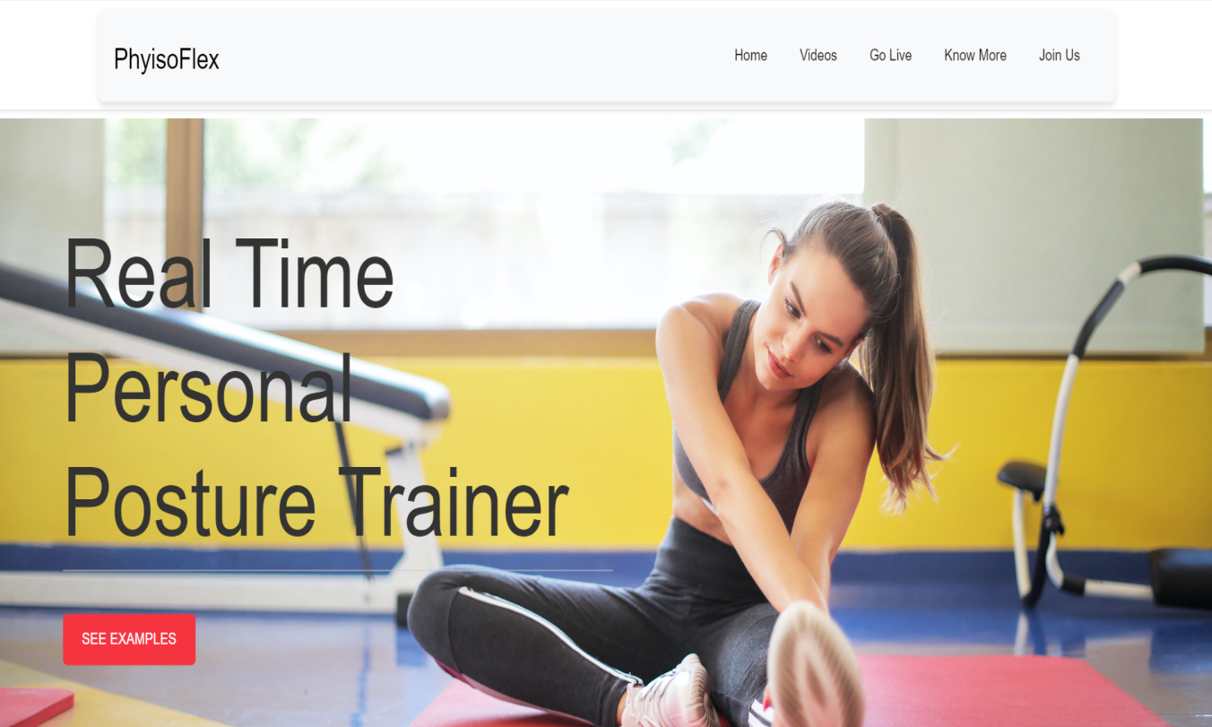

**Figure 5.1: Home Page**

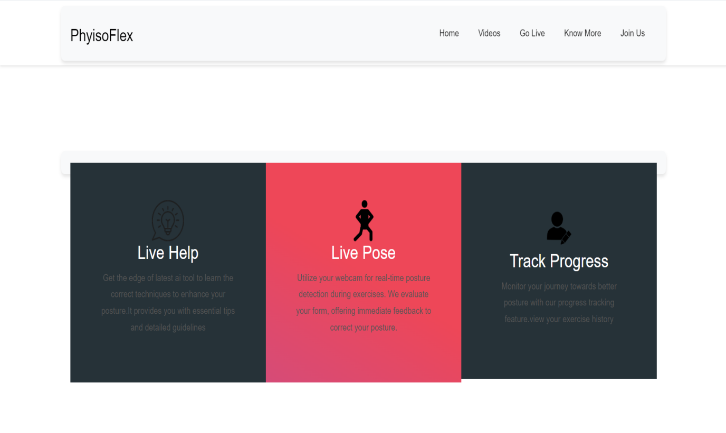

**Figure 5.2: Main Sections**

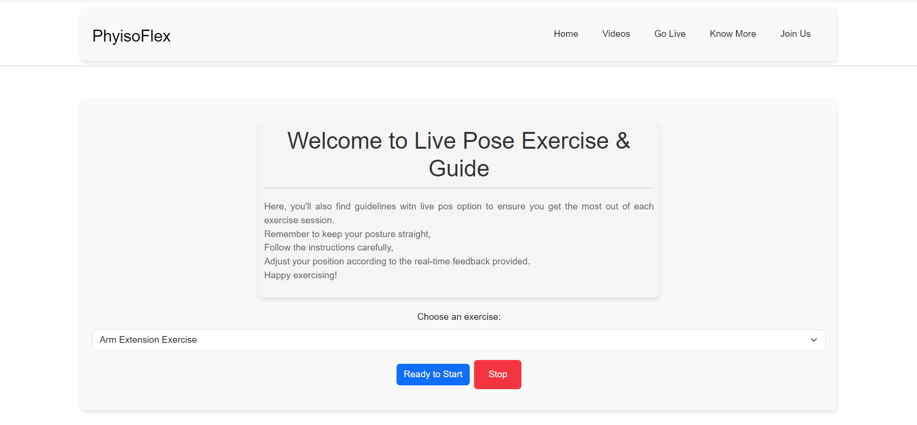

**Figure 5.3 Live Pose**

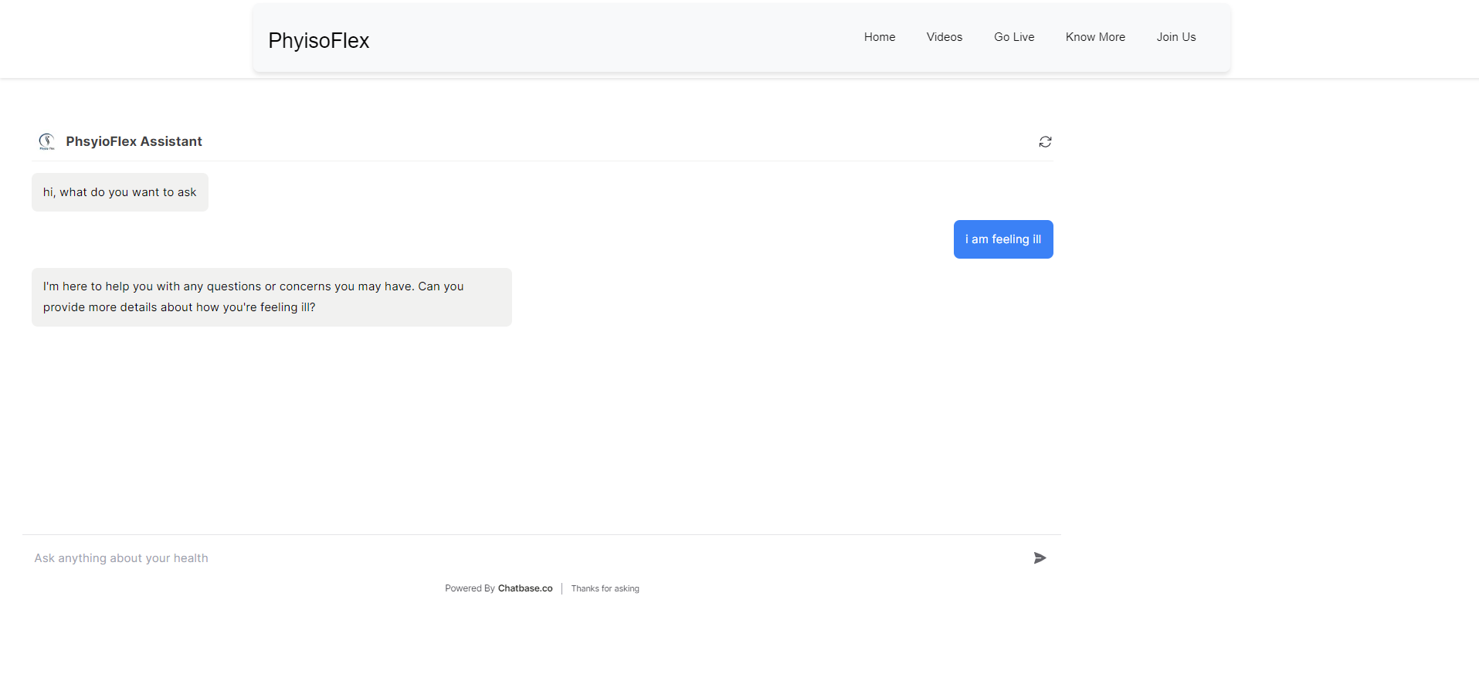

**Figure 5.4: PhysioFlex Assistant**

**Chapter 6: Testing and Evaluation**

**6.1. Verification**

Verification in Physioflex ensures that each component and functionality of the application aligns with its defined specifications and requirements. This includes verifying the accuracy of posture detection algorithms, the reliability of real time feedback mechanisms, and the effectiveness of personalized exercise recommendations based on TensorFlow.js. It also encompasses testing the integration of different modules and components to guarantee seamless functionality and data flow throughout the application. This ensures that Physioflex operates as intended and delivers accurate results to users.

**6.2. Validation**

Validation focuses on confirming that the application meets the needs and expectations of its intended users. This involves validating the usability and effectiveness of posture correction exercises, the relevance and clarity of real-time feedback, and the overall user satisfaction with the application's features and functionalities. Validation also involves gathering feedback from target users, such as individuals with musculoskeletal issues, physical therapists, and healthcare professionals, to validate that Physioflex meets their acceptance criteria and aligns with their expectations for improving posture and musculoskeletal health.

**6.3. Usability Testing**

Usability testing evaluates how easily users can navigate the application, understand the feedback provided, and engage with personalized exercise recommendations. It assesses the user interface intuitiveness, navigation flow, and user satisfaction to ensure a seamless and user-friendly experience. It may include tasks such as performing posture assessments, following exercise recommendations, interpreting feedback cues, and providing feedback on the application's ease of use and effectiveness in promoting proper posture and musculoskeletal health.

**6.4. Module / Unit Testing**

Module and unit testing in Physioflex focuses on testing individual components and units of code to ensure they function correctly and reliably. This includes testing posture detection algorithms, exercise recommendation algorithms, and feedback generation algorithms separately to validate their accuracy and performance. This includes testing posture detection algorithms to accurately identify posture deviations, validating exercise recommendation algorithms to provide tailored and effective exercise plans, and verifying feedback generation algorithms to deliver timely and informative feedback to users. Unit testing also involves testing boundary cases, error handling, and edge conditions to ensure robustness and accuracy in each component of Physioflex.

**6.5. Test cases for managing Login functionality:**

**6.5.1. Test Case 1 for Login Functionality**

Mocking database connectivity to test the login functionality.

|  |  |  |
| --- | --- | --- |
| **Input** | **Expected Output** | **Result** |
| Valid username and password | User must be login successfully | Pass |

**6.5.2. Test Case 2 for Login Functionality**

|  |  |  |
| --- | --- | --- |
| **Input** | **Expected Output** | **Result** |
| Invalid username and password | User should not be logged in and display error message | Pass |

**6.5.3. Test Case 3 for Login Functionality**

Mocking database connectivity to test the login functionality.

|  |  |  |
| --- | --- | --- |
| **Input** | **Expected Output** | **Result** |
| Empty Values for username and Password | User should not be logged and error message must display | Pass |

**6.5.4. Test case 1 for managing notification functionality:**

|  |  |  |  |
| --- | --- | --- | --- |
| **Test Case Name** | **Input** | **Expected Output** | **Result** |
| Adding a new notification information | New notification details | The notification should be successfully added to the database and viewed by user. | Pass |

**6.5.5. Test Case 2 for managing notification functionality:**

|  |  |  |  |
| --- | --- | --- | --- |
| **Test Case Name** | **Input** | **Expected Output** | **Result** |
| Updating existing notification information | Updated information for an existing notification | Notification's-details should be updated in the database and user dashboard | Pass |

**6.5.6. Test Case 3 for managing notification functionality:**

|  |  |  |  |
| --- | --- | --- | --- |
| **Test Case Name** | **Input** | **Expected Output** | **Result** |
| Deleting a notification | Pressed deleted button | Specified notification should be removed from the database and user dashboard | Pass |

**6.5.7. Test Case 4 for managing notification functionality:**

|  |  |  |  |
| --- | --- | --- | --- |
| **Test Case Name** | **Input** | **Expected Output** | **Result** |
| View notification details | View notification details button pressed | The system should return the information for the specified notification for both admin and patients. | Pass |

**6.5.8. Test Case 2 for managing notification functionality:**

|  |  |  |  |
| --- | --- | --- | --- |
| **Test Case Name** | **Input** | **Expected Output** | **Result** |
| Adding missing data fields | Attempt to add a missing required fields | The system should reject addition/update operation and display an appropriate error message | Pass |

**6.6. Integration Testing**

Integration testing in Physioflex verifies the seamless integration and interaction between different modules, components, and functionalities of the application. This includes testing how posture detection integrates with exercise recommendation logic to provide personalized exercise plans, ensuring that feedback generation synchronizes with real-time posture monitoring to deliver accurate feedback, and validating data flow and communication between various parts of the application. This ensures that Physioflex operates cohesively as a unified system, with data integrity maintained throughout different processes and interactions.

**6.7. System Testing**

System testing in Physioflex evaluates the overall behavior, performance, and reliability of the application as a whole. This includes testing end to end user workflows, data processing capabilities, system responsiveness under different loads and scenarios, and ensuring system stability and resilience. It also includes performance testing to assess how Physioflex handles concurrent user interactions, heavy data processing loads, and peak usage periods without compromising performance or user experience.

**6.8. Acceptance Testing**

Acceptance testing in Physioflex involves validating the application with real users, including individuals with musculoskeletal issues, physical therapists, and healthcare professionals. This includes gathering feedback, evaluating user satisfaction, and assessing whether Physioflex meets users' acceptance criteria and effectively addresses their musculoskeletal health needs. It also helps to validate that Physioflex aligns with user expectations, delivers tangible benefits in improving posture and musculoskeletal health, and meets the desired standards for usability, functionality, and overall user experience.

**6.9. Stress Testing**

Stress testing in Physioflex assesses the applications performance, scalability, and resilience under high load and stress conditions. This involves simulating heavy user traffic, data processing loads, concurrent user interactions, and peak usage scenarios to identify performance bottlenecks, resource limitations, and system vulnerabilities. It ensures that Physioflex can handle increased user demand, data processing requirements, and system stress without downtime, performance degradation, or functional issues, thus ensuring a robust and reliable application for users.

**6.10. Hardware Configuration for Testing**

Physioflex testing environment includes specific hardware configurations to replicate real-world usage scenarios accurately. This may involve testing the application on devices with varying screen sizes, processing capabilities, input methods, and network conditions to validate cross-platform compatibility, performance optimization, and hardware compatibility. Hardware configuration for testing ensures that Physioflex operates effectively on different devices, platforms, and environments, delivering consistent functionality and user experience across diverse hardware configurations.

**6.11. Evaluation**

1. **Testing Metrics Analysis:**

Evaluation involves analyzing various testing metrics collected during the testing phases, such as verification, validation, usability testing, performance testing, and user acceptance testing. Metrics may include accuracy rates of posture detection algorithms, user satisfaction scores, system response times, error rates, and scalability metrics under stress testing conditions.

2. **Identification of Issues and Gaps**:

Evaluation includes identifying any issues, bugs, or gaps discovered during testing. This involves categorizing issues based on severity, impact on functionality, and user experience. Common issues may include algorithm inaccuracies in posture detection, usability challenges in navigating the interface, performance bottlenecks under heavy load, or compatibility issues across different devices.

3. **Prioritization of Enhancements**:

Based on the evaluation findings, enhancements and improvements are prioritized to address identified issues and enhance Physio flex's functionality, usability, performance, and reliability. Prioritization involves categorizing enhancements into critical, high-priority, medium-priority, and low-priority items based on their impact on user experience and application functionality.

4. **Data-Driven Decision Making:**

Evaluation in Physioflex emphasizes data-driven decision making, leveraging testing results, user feedback, and performance metrics to guide decision-making processes. This involves analyzing qualitative and quantitative data to make informed decisions about feature enhancements, bug fixes, performance optimizations, and usability improvements.

5. **Iterative Refinement Process:**

Evaluation drives an iterative refinement process in Physioflex, where identified issues are addressed, enhancements are implemented, and new features are added based on user needs and feedback. This iterative approach ensures continuous improvement and evolution of Physioflex to meet user expectations and industry standards.

6. **User Feedback Incorporation:**

It includes incorporating user feedback gathered during usability testing, acceptance testing, and beta testing phases. User feedback is valuable in understanding user preferences, pain points, and feature requests, guiding enhancements and updates to align Physioflex with user expectations and preferences.

**6.12. Deployment**

1. **Production Environment Setup**:

Deployment of Physioflex involves setting up the production environment, including configuring servers, databases, network infrastructure, and security measures. This ensures a robust and secure environment for hosting Physioflex and managing user data securely.

2. **Quality Assurance Checks:**

Before deployment, quality assurance checks are conducted to ensure that Physioflex meets all quality standards, including functionality, performance, security, and usability. This involves final testing and validation to confirm that all identified issues have been addressed, and the application is ready for production release.

3. **Roll-out Strategy:**

A roll out strategy is defined for deploying Physioflex to users, healthcare providers, and stakeholders. This may include phased roll out to specific user groups, geographical regions, or targeted audiences to manage deployment risks, gather feedback, and ensure a smooth transition to the live environment.

4. **Version Control and Release Management:**

Version control and release management processes are implemented to track changes, manage code versions, and ensure controlled deployment of updates and new features. This includes documenting release notes, managing dependencies, and coordinating release schedules to minimize disruptions and ensure compatibility.

5**. Post-Deployment Monitoring**:

After deployment, ongoing monitoring and performance evaluation are conducted to assess Physio flex's performance in the production environment. This involves monitoring system health, user activity, performance metrics, error logs, and security incidents to detect and address any issues promptly.

6. **User Training and Support:**

User training and support resources are provided to users, healthcare providers, and administrators to familiarize them with Physio flex's features, functionalities, and best practices. This includes user guides, tutorials, help documentation, and access to technical support channels for assistance and troubleshooting.

7. **Continuous Improvement and Updates:**

Deployment of Physioflex is followed by a commitment to continuous improvement and updates. This involves gathering user feedback, monitoring application performance, identifying areas for enhancement, and releasing updates, patches, and new features to enhance user experience, address emerging needs, and stay competitive in the market.

8. **Compliance and Data Security:**

Deployment includes ensuring compliance with regulatory requirements, data protection laws, and industry standards related to healthcare data privacy and security. This includes implementing data encryption, access controls, audit trails, and security protocols to protect user data and maintain regulatory compliance.

**6.13. Maintenance**

1. **Bug Fixes and Issue Resolution:**

Continuous monitoring and addressing of bugs, errors, and issues reported by users or identified through monitoring systems. This includes prompt investigation, debugging, and deployment of fixes to maintain application functionality and user experience.

2. **Performance Monitoring and Optimization:**

Ongoing monitoring of application performance metrics such as response times, resource utilization, and system stability. Optimization efforts focus on improving performance, scalability, and efficiency through code optimizations, database tuning, and infrastructure upgrades as needed.

3. **Security Updates and Vulnerability Management**:

Regular security assessments, vulnerability scans, and updates to protect against cyber security threats. This includes applying security patches, implementing security best practices, securing data transmission, and ensuring compliance with data protection regulations.

4. **Data Management and Backup Strategies:**

Implementing data management practices to ensure data integrity, availability, and confidentiality. This includes regular data backups, disaster recovery planning, data retention policies, and data encryption to safeguard sensitive user information.

5. **User Support and Training:**

Providing ongoing user support through help desk services, technical assistance, and troubleshooting guidance. User training materials, documentation, and resources are updated and maintained to help users navigate the application effectively and maximize its benefits.

6. **Version Control and Release Management:**

Managing version control for application updates, patches, and new releases. This includes maintaining a release schedule, documenting release notes, managing dependencies, and ensuring smooth deployment of updates to minimize disruptions.

7**. Feedback Collection and Analysis:**

Continuously gathering user feedback, feature requests, and suggestions for improvement. Feedback analysis informs prioritization of enhancements, usability improvements, and new feature development to align the application with user needs and expectations.

8. **Performance Testing and Monitoring:**

Conducting periodic performance testing and monitoring to assess application scalability, reliability, and responsiveness. This includes load testing, stress testing, and performance tuning to maintain optimal performance under varying usage conditions.

9. **User Engagement and Community Building:**

Engaging with users, stakeholders, and the healthcare community to foster a collaborative environment. This includes participation in user forums, community discussions, and feedback sessions to gather insights, build relationships, and promote user engagement with Physioflex.

10. **Technology Upgrades and Innovation:**

Keeping abreast of technological advancements, frameworks, and tools relevant to musculoskeletal health and digital healthcare. This includes evaluating new technologies, incorporating innovative features, and leveraging emerging trends to enhance Physio flex's capabilities and user experience.

**Chapter 7: Conclusion and Future Work**

**7.1. Conclusion**

Physioflex represents a groundbreaking advancement in addressing musculoskeletal health through technology-driven solutions. Its real-time posture feedback, personalized exercise recommendations, and user-centric design have led to tangible improvements in posture awareness, discomfort reduction, and overall well-being for users. By bridging the gap between technology and healthcare, Physioflex has not only empowered individuals to take proactive steps towards better posture but has also contributed to a broader conversation on preventive care, digital wellness, and the integration of technology in promoting healthier lifestyles. Looking ahead, Physio flex's commitment to continuous innovation, user engagement, and collaborative partnerships ensures a future where musculoskeletal health management is accessible, personalized, and impactful for users worldwide.

**7.2. Future Work**

1. Invest in further research and development to improve the accuracy, sensitivity, and specificity of posture detection algorithms used in Physioflex. Explore machine learning techniques, data augmentation strategies, and sensor integration for more precise and comprehensive posture assessment.
2. Explore innovative feedback mechanisms, such as augmented reality (A visualizations, haptic feedback, or gamification elements, to enhance user engagement and effectiveness of posture correction cues).
3. Personalized Exercise Recommendations: Expand the range of personalized exercise recommendations in Physioflex, incorporating diverse exercises targeting specific musculoskeletal issues, mobility challenges, and ergonomic adjustments.
4. Integration with Wearable Devices: Explore integration with wearable devices and sensors to capture real-time posture data, monitor physical activity levels, and provide personalized feedback and reminders for posture correction throughout the day.
5. Data Analytic and Insights: Leverage data analytic and machine learning techniques to derive actionable insights from user data collected by Physioflex, enabling personalized interventions, trend analysis, and predictive modeling for musculoskeletal health outcomes.
6. Telehealth and Remote Monitoring: Explore opportunities for integrating Physioflex with telehealth platforms, enabling remote consultations, virtual coaching sessions, and continuous monitoring of users' progress in posture correction and exercise adherence.
7. Accessibility and Inclusivity Features: Enhance Physio flex's accessibility features to cater to diverse user needs, including support for different languages, accessibility settings for users with disabilities, and inclusive design principles for a broader user base.
8. Clinical Validation and Research Collaborations: Collaborate with healthcare institutions, research organizations, and clinical experts to validate the efficacy of Physioflex in clinical settings, conduct longitudinal studies on posture improvement outcomes, and contribute to evidence based practices in musculoskeletal health.
9. User Engagement and Education Initiatives: Launching user engagement campaigns, educational materials, and community initiatives to raise awareness about musculoskeletal health, promote healthy posture habits, and foster a supportive user community around Physioflex.
10. Scalability and Global Reach: Plan for scalability and global expansion of Physioflex, considering localization for different regions, compliance with international healthcare standards, and scalability of infrastructure to accommodate growing user populations.

**References**

1. https://play.google.com/store/apps/details?id=com.physitrack.physiapp
2. <https://www.usa.edu/blog/virtual-physical-therapy/>
3. https://onlinelibrary.wiley.com/doi/10.1155/2020/6625797
4. <https://my.clevelandclinic.org/health/treatments/physical-therapy>
5. <https://www.virtualphysicaltherapists.com/>
6. <https://www.wired.com/review/upright-go-2/>